**VISUALIZATION TOOLS FOR ELECTRIC VEHICLE CHARGE**

**AND RANGE ANALYSIS**

INTRODUCTION

OVERVIEW

A vehicle that can be powered by an electric motor that draws electricity from a battery and is capable of being charged from an external source and have an electric motor instead of an internal combustion engine. The Electric Vehicle (EV) is not new, but it has been receiving significantly more attention in recent years. Advances in both EV analytics and battery technologies have led to increased automotive market share. However, this growth is not attributed to hardware alone.

The modern mechatronic vehicle marries electrical storage and propulsion systems with electronic sensors, controls, and actuators, integrated closely with software, secure data transfer, and data analysis, to form a comprehensive transportation solution. Advances in all these areas have contributed to the overall rise of EV’s, but the common thread that runs through all these elements is data analytics.

The new EV’s are combined Electrical storage and propulsion systems with electronic sensors, controls, and actuators, integrated closely with software, secure data transfer to form a comprehensive transportation solution.

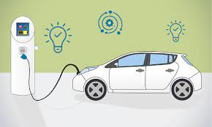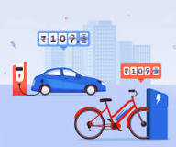

2.1 PURPOSE

Electric vehicles use electricity to charge their batteries instead of using fossil fuels like petrol or diesel. Electric vehicles are more efficient, and that combined with the electricity cost means that charging an electric vehicle is cheaper than filling petrol or diesel for your travel requirements.

2.2 PROBLEM DEFINING AND DESIGN THINKING

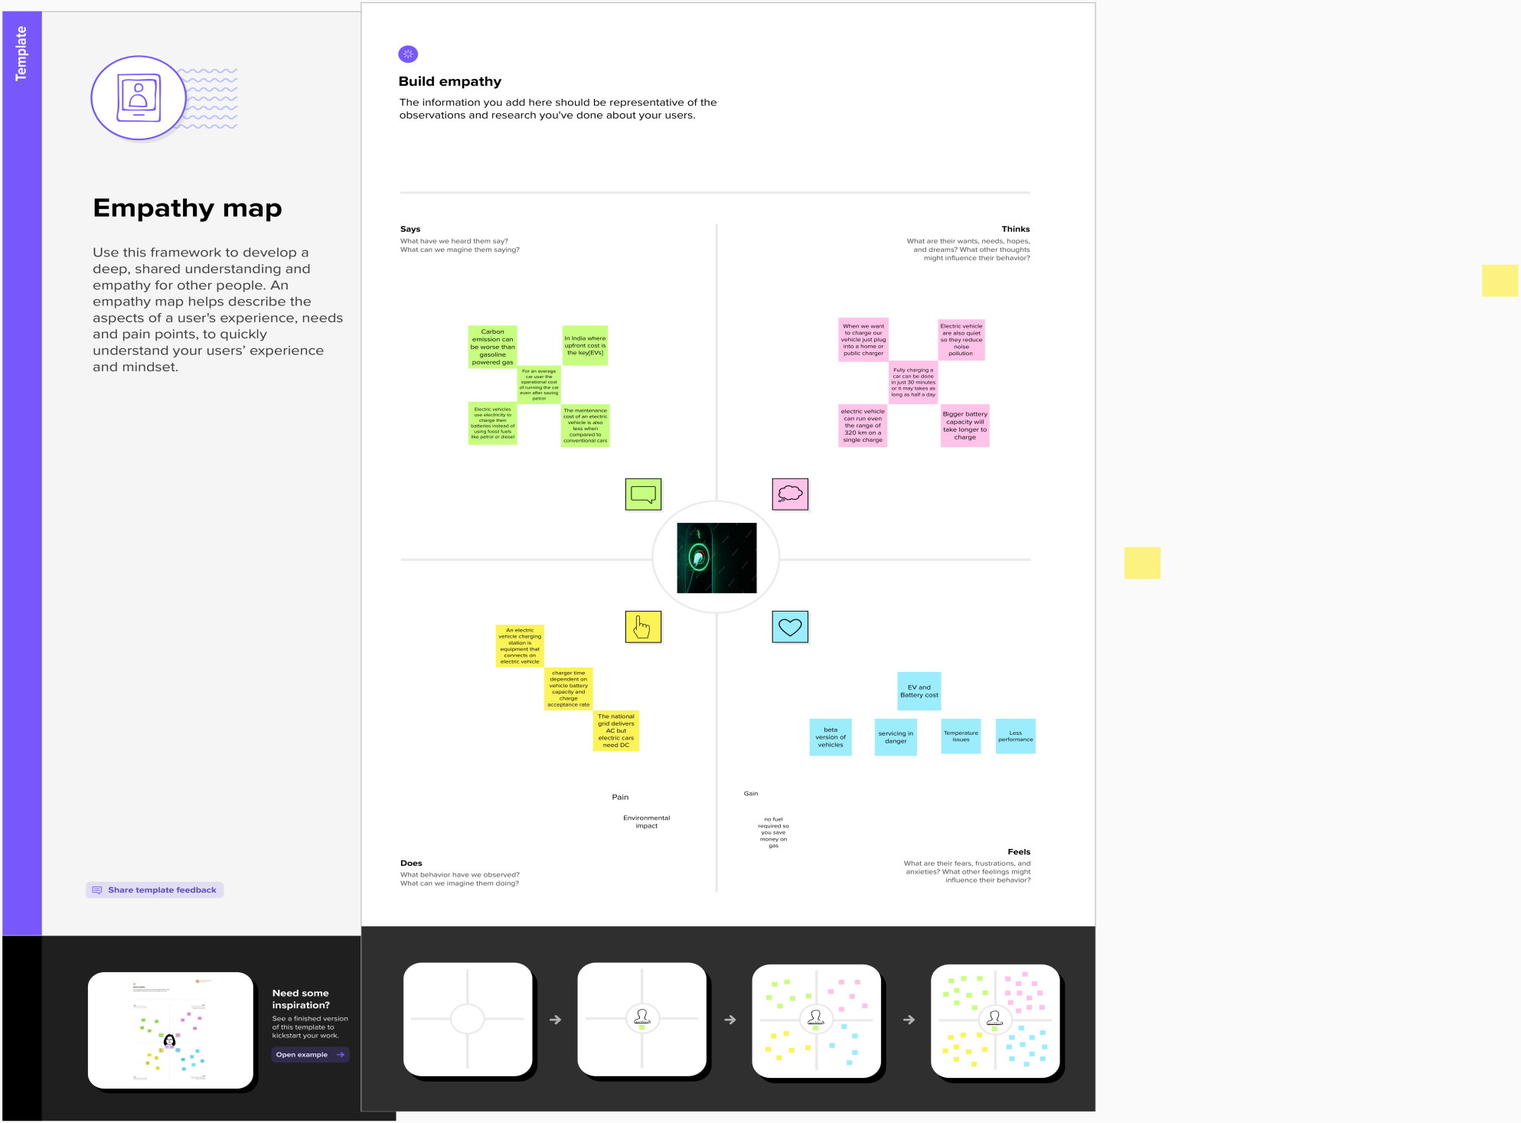

IDEATION AND BRAINSTORMING

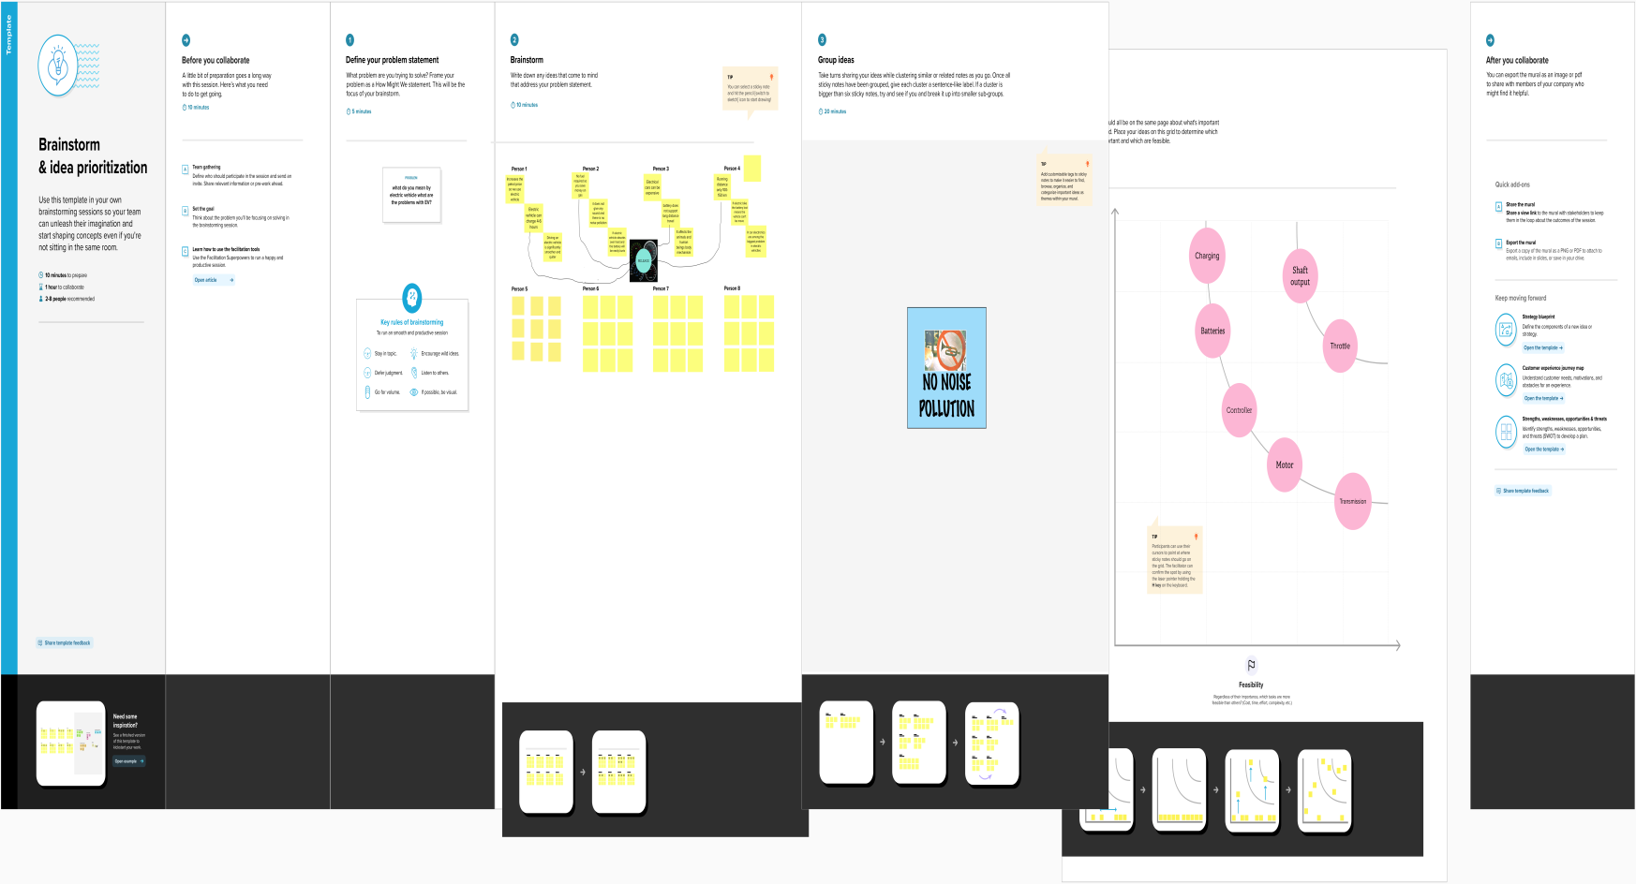

3.RESULT

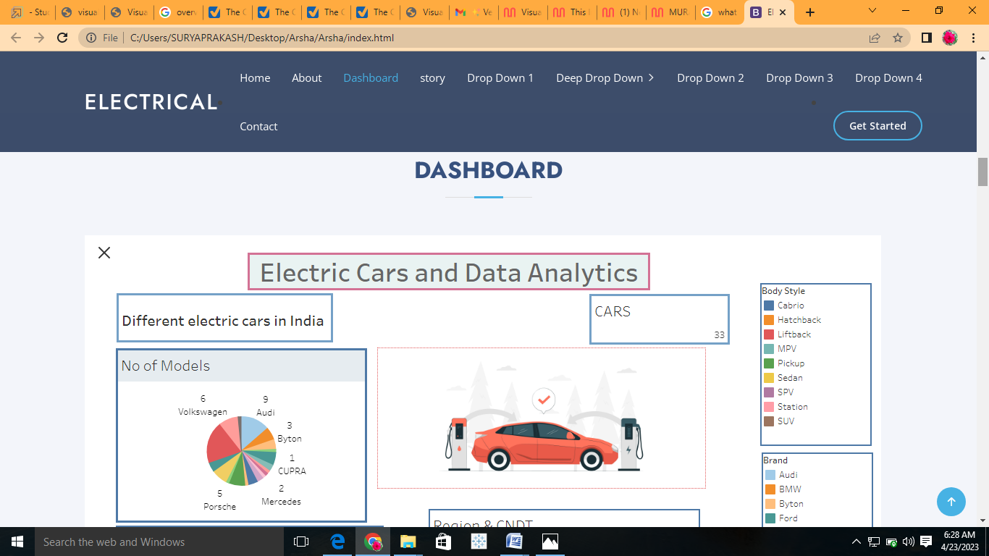

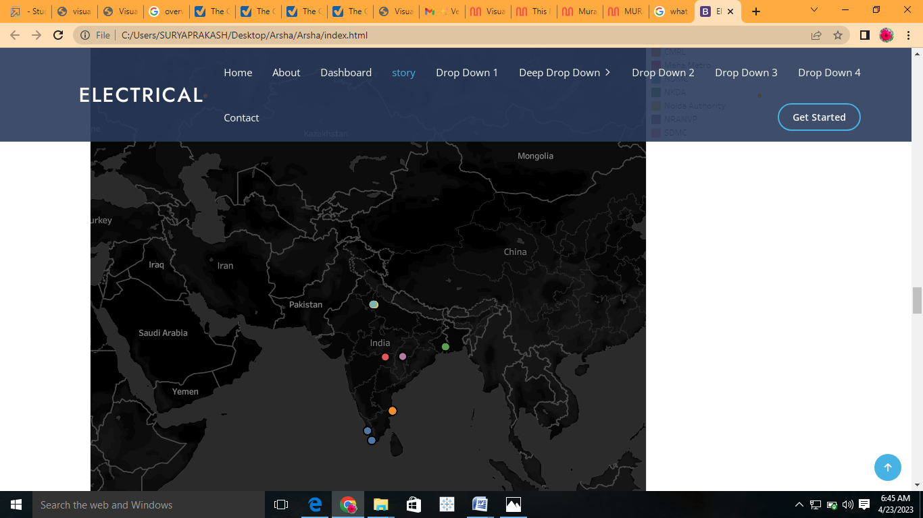

**4.ADVANTAGES**

* **Eco-friendly**
* **Renewable energy source**
* **Less noise and smoother motion**
* **Cost-effective**
* **Low maintenance**
* **Government support**

**DISADVANTAGES**

* **High initial cost**
* **Charging station limitations**
* **Recharging takes time**
* **Limited options**
* **Less driving range**

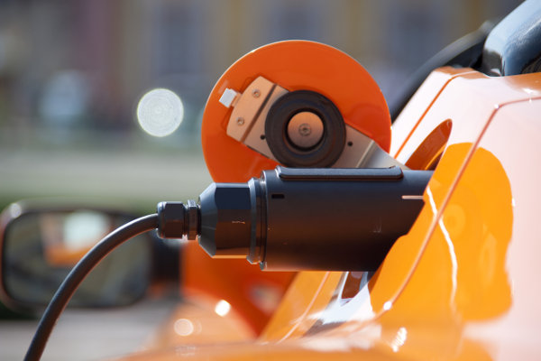**5.APPLICATIONS OF ELECTRIC VEHICLES**

Burning coal or natural gas at a generation plant to produce electricity to later power electric cars is clearly not the smartest way to reduce pollution and CO2emissions—although still better than gasoline vehicles.

What’s exciting about electric cars is the near future:

* Distributed [solar](http://www.flashchargebatteries.com/applications/renewable-energy-storage/) in rooftops, charging…
* Clean batteries—hopefully, FlashCharge Batteries—in the basements, that charge…
* Electric cars at any time of the day or night in 15 minutes or less—hopefully, cars powered by FlashCharge Batteries.

**CONCLUSION OF ELECTRIC VEHICLES**

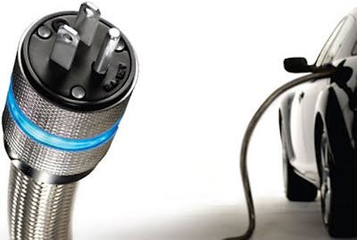

The biggest obstacle to the widespread adoption of electric-powered transportation is cost related, as gasoline and the vehicles that run on it are readily available, convenient, and less costly. As is demonstrated in our timeline, we hope that over the course of the next decade technological advancements and policy changes will help ease the transition from traditional fuel-powered vehicles.

Each person can make a difference, so go electric and help make a difference!

**FUTURE SCOPE**

Electric car manufacturing is getting increasingly popular, and its market share is likely to grow significantly. By 2022, India's GDP is predicted to increase by a staggering 25%.

The best aspect is that, in addition to decreasing pollution, EVs can reduce oil imports by $60 billion by 2030. Currently, imports account for 82 per cent of India's oil requirement. As a result, it is clear how helpful it will be for the Indian economy if the import cost is decreased.

**APPENDIX**

**SOURCE CODE**

<!-- ======= Services Section ======= -->

    <section id="services" class="services section-bg">

      <div class="container" data-aos="fade-up">

        <div class="section-title">

          <h2>Dashboard</h2>

        </div>

       <div class='tableauPlaceholder' id='viz1682057410684' style='position: relative'><noscript><a href='#'><img alt='Dashboard 1 ' src='https:&#47;&#47;public.tableau.com&#47;static&#47;images&#47;EL&#47;ELECTRICCARSANDDATAANALYTICS&#47;Dashboard1&#47;1_rss.png' style='border: none' /></a></noscript><object class='tableauViz'  style='display:none;'><param name='host_url' value='https%3A%2F%2Fpublic.tableau.com%2F' /> <param name='embed_code_version' value='3' /> <param name='site_root' value='' /><param name='name' value='ELECTRICCARSANDDATAANALYTICS&#47;Dashboard1' /><param name='tabs' value='no' /><param name='toolbar' value='yes' /><param name='static_image' value='https:&#47;&#47;public.tableau.com&#47;static&#47;images&#47;EL&#47;ELECTRICCARSANDDATAANALYTICS&#47;Dashboard1&#47;1.png' /> <param name='animate_transition' value='yes' /><param name='display_static_image' value='yes' /><param name='display_spinner' value='yes' /><param name='display_overlay' value='yes' /><param name='display_count' value='yes' /><param name='language' value='en-US' /></object></div>                <script type='text/javascript'>                    var divElement = document.getElementById('viz1682057410684');                    var vizElement = divElement.getElementsByTagName('object')[0];                    if ( divElement.offsetWidth > 800 ) { vizElement.style.width='1100px';vizElement.style.height='2527px';} else if ( divElement.offsetWidth > 500 ) { vizElement.style.width='1100px';vizElement.style.height='2527px';} else { vizElement.style.width='100%';vizElement.style.height='3427px';}                     var scriptElement = document.createElement('script');                    scriptElement.src = 'https://public.tableau.com/javascripts/api/viz_v1.js';                    vizElement.parentNode.insertBefore(scriptElement, vizElement);                </script>

          </div>

,

        </div>

      </div>

    </section><!-- End Services Section -->

 <!-- ======= Portfolio Section ======= -->

    <section id="portfolio" class="portfolio">

      <div class="container" data-aos="fade-up">

        <div class="section-title">

          <h2>story</h2>

           <div class='tableauPlaceholder' id='viz1682057722716' style='position: relative'><noscript><a href='#'><img alt='STORY OF ELECTRIC CARS IN INDIA ' src='https:&#47;&#47;public.tableau.com&#47;static&#47;images&#47;4K&#47;4KG7HXQY9&#47;1_rss.png' style='border: none' /></a></noscript><object class='tableauViz'  style='display:none;'><param name='host_url' value='https%3A%2F%2Fpublic.tableau.com%2F' /> <param name='embed_code_version' value='3' /> <param name='path' value='shared&#47;4KG7HXQY9' /> <param name='toolbar' value='yes' /><param name='static_image' value='https:&#47;&#47;public.tableau.com&#47;static&#47;images&#47;4K&#47;4KG7HXQY9&#47;1.png' /> <param name='animate_transition' value='yes' /><param name='display_static_image' value='yes' /><param name='display_spinner' value='yes' /><param name='display_overlay' value='yes' /><param name='display_count' value='yes' /><param name='language' value='en-US' /></object></div>                <script type='text/javascript'>                    var divElement = document.getElementById('viz1682057722716');                    var vizElement = divElement.getElementsByTagName('object')[0];                    vizElement.style.width='1016px';vizElement.style.height='991px';                    var scriptElement = document.createElement('script');                    scriptElement.src = 'https://public.tableau.com/javascripts/api/viz_v1.js';                    vizElement.parentNode.insertBefore(scriptElement, vizElement);                </script>

          </div>

          </div>

        </div>

      </div>

    </section><!-- End Portfolio Section -->